**“Comprehensive Analysis of Attacks on the OSI Model: Case Studies and Report “**

1. **Research Attacks on the OSI Mode :**

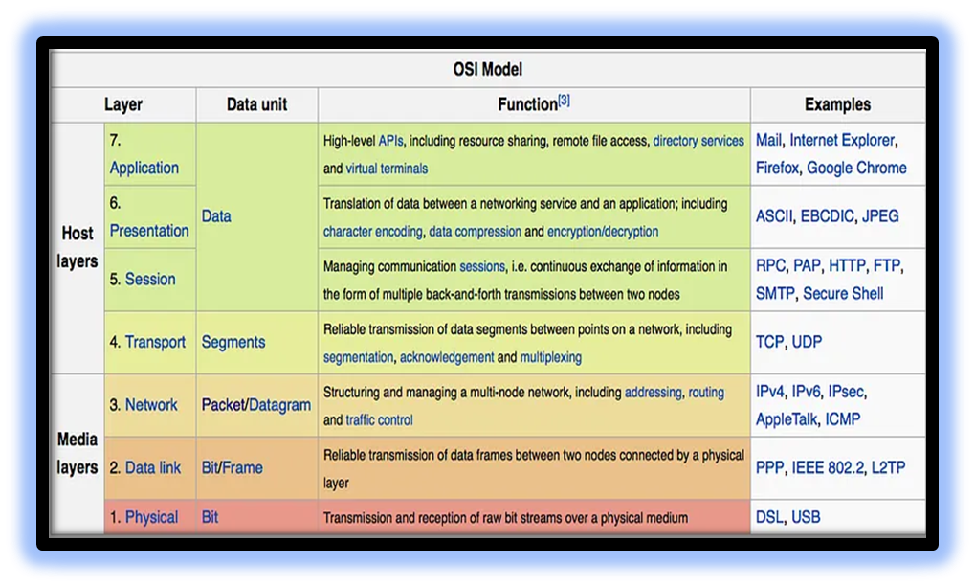**OSI Model:** Open systems Interconnection Model

The OSI model is a 7-layer framework that explains how computer networks communicate. It helps to organize and understand how data is transmitted and received.

Layers are classified into two categories:

* **Host layers**: Application layer, Presentation layer, Session layer and the Transport layer.
* **Media layers**: Network layer, Data link layer and physical layer.

**Attacks on OSI Model:** Attacks can occur at various levels of network models, each with different protocols.

1. **PHYSICAL LAYER: (SNIFFING)**

Back in the day when there was no remote home phone , having multiple phones at home led to issues where someone could pick up another phone and eavesdrop on conversations. So, in network security, without encryption, unencrypted packets can be intercepted by intruders using sniffing applications like Wireshark, Tcp Dump, or Win Dump, which operate at the physical layer of the OSI model. This highlights the importance of encryption to protect network data from unauthorized access.

some examples of protocols that operate at the physical layer and can be intercepted by sniffing applications:

* Ethernet
* Wi-Fi
* Bluetooth
* Zigbee

1. **DATALINK LAYER: (SPOOFING)**

Spoofing is when someone or a program pretends to be from a trusted source, but actually comes from an unknown source. It can happen in emails, phone calls, websites, or in more technical ways like spoofing an IP address, ARP, or DNS server.

IP and ARP spoofing can be used in man-in-the-middle attacks on computer networks. To protect against these attacks, firewalls with deep packet inspection or verifying the sender or recipient's identity can be used.

1. **Network Layer: (Man-In-the- Middle)**

Some protocols in the TCP/IP suite lack authentication mechanisms, allowing attackers to secretly intercept and modify communication between two parties who believe they are directly communicating.

This vulnerability enables attackers to perform man-in-the-middle attacks, relaying and potentially altering the messages without the knowledge of the communicating parties.

1. **TRANSPORT LAYER: (RECONNAISSANCE)**

In cybersecurity, reconnaissance refers to gathering information about a system. A key technique is port scanning, which tests TCP and UDP ports for responses.

Common examples of reconnaissance attacks include packet sniffing, ping sweeping, port scanning, phishing, social engineering, and internet information queries.

1. SESSION LAYER: (HIJACKING**)**

Session hijacking, also known as cookie hijacking, is when someone exploits a computer session to gain unauthorized access to information or services.

It involves stealing a "magic cookie" that authenticates a user to a remote server. Web developers should be aware of this as attackers can easily steal HTTP cookies, which maintain website sessions, through an intermediary computer or by accessing saved cookies on a victim's computer.

Session hijacking attacks can be carried out through various methods.

**Cross-site scripting (XSS):** attacks involve injecting malicious scripts into web pages, tricking victims' browsers into executing them as if they came from a trusted source. This allows attackers to access sensitive information like cookies or carry out unauthorized operations on the victim's computer, posing significant security risks.

**Session side jacking:** when an attacker uses packet sniffing to intercept network traffic and steal session cookies.

**Malware**: It can hijack browsers to silently steal cookie files, allowing unauthorized access without the user's awareness.

1. **PRESENTATION: (PHISHING)**

Phishing attacks involve sending fraudulent messages, often via email, pretending to be from a trustworthy source. The aim is to trick recipients into sharing sensitive information or unknowingly installing malware. It's a widespread cyber attack that everyone should be aware of to safeguard their personal data and online security.

1. **APPLICATION LAYER: (EXPLOIT)**

An exploit is a program that capitalizes on vulnerabilities or bugs in systems. These vulnerabilities can stem from poor system configuration or software bugs. Exploits are often used to gain elevated access to a victim's system or to launch DoS/DDoS attacks, which can disable websites or critical systems without requiring an exploit itself.

Attacks on the OSI model exploit vulnerabilities across layers. It helps implement layered security measures for network protection, fostering a defense-in-depth approach to safeguard systems.

1. **Real-World Case Studies:**

**Analyze two real-world case studies of attacks on the OSI**

**Model.**

Real world case study from 2022, It’s Focuses on attacks on different layers of the OSI model, their impact, consequences, and countermeasures.

* **CASE STUDY 1:** **Distributed Denial of Service (DDoS) Attack**

**BACKGROUND:** 2022: E-commerce platform hit by a DDoS attack, impacting multiple OSI model layers, causing hours of service disruption.

**LAYER 1 : Physical Layer**

In 2022, attackers used a botnet of infected devices to flood an e-commerce platform's network. By leveraging this botnet, they overwhelmed the network with massive traffic, causing a slowdown and making the website inaccessible to legitimate users.

**Impact:** The DDoS attack overwhelmed the e-commerce platform's physical network infrastructure, causing a significant slowdown in performance.

**Consequences**: The platform's website became inaccessible to legitimate users, resulting in a loss of revenue and reputation.

**LAYER 2: Data Link Layer** To enhance the attack, the attackers used techniques like MAC flooding and ARP poisoning. By flooding the network switches with fake MAC addresses or manipulating ARP tables, they overwhelmed the switches and caused network congestion.

**Impact:** The attack at the data link layer led to increased network latency, packet loss, and disrupted network connectivity.

**Consequences:** Legitimate traffic faced difficulties reaching its destination, causing further degradation of services for the e-commerce platform. The compromised switches experienced performance degradation and potential instability.

**LAYER3: NETWORK LAYER**

In this attackers used IP spoofing, forging the source IP addresses of malicious packets. This obscured the attack's true origin and made it challenging to mitigate. IP-based filtering security measures were bypassed, giving the attackers an advantage.

**Impact:** IP spoofing made it difficult for the e-commerce platform to effectively identify and block malicious traffic, leading to prolonged service disruption.

**Consequences:** The network security infrastructure struggled to distinguish between legitimate and spoofed packets, resulting in prolonged mitigation efforts and extended disruption of services.

**Countermeasures** :

* **Network Traffic Monitoring:** Used robust tools to detect unusual traffic patterns and identify potential DDoS attacks in real-time.
* Traffic Filtering: Implemented intelligent mechanisms to differentiate between legitimate and malicious traffic, dropping or mitigating the latter.
* **Load Balancing:** Distributed traffic across multiple servers to mitigate the impact on a single server.
* **Redundancy and Scalability:** Ensured network infrastructure had redundancy and scalability to absorb and mitigate high-volume DDoS attacks. Intrusion Detection and Prevention Systems (IDPS): Deployed IDPS solutions to detect and block network layer attacks, including IP spoofing and unusual traffic patterns.

This case study shows how a DDoS attack targeted an e-commerce platform, impacting its physical network, data link layer, and network layer. The platform defended itself using monitoring, filtering, load balancing, redundancy, and IDPS solutions, reducing the attack's impact and protecting its services.

* **CASE STUDY 2:**  **Solar Winds Supply Chain Attack**

In 2020, the SolarWinds attack targeted a network management software provider. It resulted in a major breach that affected government agencies and companies worldwide. The attackers injected a hidden malware into legitimate software updates, compromising sensitive data. It highlighted the need for improved supply chain security and heightened cybersecurity measures.

**LAYER 7: Application Layer**

Attackers targeted SolarWinds' software build system, injecting a backdoor into the company's Orion software updates. This resulted in legitimate updates distributing hidden malware. Numerous organizations using the compromised software were vulnerable to unauthorized access. It underscored the significance of securing software build processes and verifying the integrity of software updates.

**Impact:**

The Solar Winds attack breached multiple OSI layers, causing a massive data breach. Attackers gained access to sensitive information, including emails, source code, and intellectual property. Government agencies, major tech companies, and organizations globally were compromised, posing a significant risk to national security and data privacy.

**Consequences:** The SolarWinds attack resulted in severe consequences, including unauthorized access to critical systems, potential data exfiltration, and a loss of trust in SolarWinds. Compromised organizations invested significant time, effort, and resources to identify, mitigate, and investigate the breach.

**Countermeasures:** In response to the SolarWinds attack, organizations and security experts implemented various countermeasures to enhance cybersecurity:

* **Enhanced Supply Chain Security:** Assessing software vendors and suppliers for security, conducting due diligence, and implementing robust vendor risk management programs.
* **Zero Trust Architecture:** Verifying and authenticating all entities accessing network resources, regardless of trust level or location.
* **Intrusion Detection and Prevention Systems (IDPS):** Deploying IDPS solutions to detect and prevent supply chain attacks, identifying malicious activities and abnormal behavior.
* **Security Information and Event Management (SIEM):** Using SIEM solutions to monitor network traffic, detect anomalies, and analyze security events centrally.
* **Incident Response Planning**: Developing and updating incident response plans, defining roles, conducting drills, and ensuring an effective response process.

The SolarWinds attack exposed supply chain vulnerabilities and emphasized the importance of multi-layered defenses. Lessons learned include improving supply chain security, network monitoring, access controls, and incident response planning to mitigate risks and enhance cybersecurity practices.

**3. Group Collaboration and Knowledge Sharing:**

To engage in a discussion to foster a comprehensive understanding of attacks across the OSI model. It is a conceptual framework that defines how different network protocols communicate with each other. It consists of seven layers, each responsible for a specific set of functions. Each layer has its own protocols and functions, and attacks can target vulnerabilities at various layers.

* **Physical Layer:**

The physical layer transmits raw bits. **Attacks:** involve tampering with infrastructure, like cutting cables or tapping communication lines physically. **Risk:** include network disruption, data loss, and unauthorized access.

* **Data link Layer:**

The data link layer ensures reliable data transmission between connected nodes.

**Attack:** involve MAC address spoofing, where an attacker modifies their MAC address to impersonate a legitimate device, potentially gaining unauthorized access to the network.

**Risk:** include unauthorized access, data interception, and network congestion.

* **Network Layer:**

The network layer routes data packets and assigns logical addresses.

**Attacks:** involve IP spoofing, where an attacker manipulates packet source IP addresses to deceive recipients and perform unauthorized actions, potentially bypassing security measures.

**Risk:** include traffic interception, denial of service (DoS), and unauthorized access.

* **Transport Layer:**

The transport layer guarantees data delivery between hosts.

**Attacks:** exploit vulnerabilities in protocols like TCP or UDP. For instance, TCP SYN flooding or UDP flooding overwhelms a system by flooding it with excessive connection requests, causing disruption or denial of service.

**Risk:** include data loss, service disruption, and unauthorized access to sensitive information.

* **Session Layer:**

The session layer handles communication sessions between applications.

**Attacks:** involve session hijacking, where an attacker seizes control of an ongoing session to gain unauthorized access to data or resources, compromising the session's integrity and confidentiality.

**Risk:** include unauthorized access, data interception, and compromised session integrity.

* **Presentation Layer:**

The presentation layer manages data formatting and encryption.

**Attacks:** exploit vulnerabilities in compression algorithms, encryption protocols, or manipulate data formats to deceive the receiving application, potentially compromising data integrity, confidentiality, or security measures.

**Risk:** include unauthorized access, data leakage, and compromised data integrity.

* **Application Layer:**

The application layer delivers services to end-users.

**Attacks:** focus on specific applications or services, like cross-site scripting (XSS), SQL injection, or phishing, exploiting vulnerabilities in web applications to gain unauthorized access or manipulate user data.

**Risk:** include data breaches, unauthorized access, and service disruption.

**NOTE:**  It's important to realize that attacks can target multiple layers at once, as vulnerabilities in one layer affect higher layers. Understanding these attacks and their impact is vital for implementing effective security measures, safeguarding network communications, and ensuring data integrity, confidentiality, and availability.

* 1. **Comprehensive Report:**

OSI (Open Systems Interconnection) model in a more human-friendly way.

In network, which is basically a bunch of devices like computers, servers, routers, and switches connected to each other. These devices need to communicate with each other to exchange information, like sending emails or browsing the web. The OSI model is like a blueprint that describes how this communication happens. It breaks down the entire process into seven layers, each with its own specific role and responsibility. So, Let's think of it as sending a letter. In this analogy, you are the sender and your friend is the receiver. The seven layers of the OSI model represent different tasks involved in getting the letter delivered. In this layer Represented from Top to Bottom:

* **Application Layer:** The Application layer is like the actual letter itself, with its meaningful content. It represents the specific applications or services that use the network like email, web browsing, or file sharing. It’sprovides the user interface and handles message and packet generation.
* **Protocols**: It uses the protocols FTP, HTTP, POP3, & SMTP and its device is a gateway.
* **Example of DOS technique that can be applied at this layer:**

PDF GET requests, HTTP Get, HTTP POST, = website forms (login, uploading photo/video, submitting feedback)

* **Impact:** When a service runs out of resources, it can cause slowdowns, crashes, or complete failure. This can impact other dependent services, resulting in system-wide problems and failures. It's like a domino effect within the system.
* **Mitigation:** Application monitoring involves using specialized algorithms and technologies to detect and prevent zero-day attacks and attacks targeting application layers. By quickly identifying these threats, they can be stopped and traced back to their source more effectively, making it easier to mitigate the impact of such attacks compared to other types of DDoS attacks.
* **Presentation Layer:** It is like translating the content of your letter into a language your friend can understand. It takes care of things like data encryption, compression, and formatting, so that the receiver can make sense of the information. It ensures that applications can understand and exchange data in a compatible format. It also handles encryption and decryption to protect the confidentiality and integrity of data during network transmission.
* **Protocols:** Compression and Encryption.
* **Example of DOS technique that can be applied at this** layer:

Malformed SSL Requests -- Inspecting SSL encryption packets as resource intensive. Attackers use SSL to tunnel HTTP attacks to target the server.

* **Impact:** A DOS attack can cause SSL service disruptions, leading to clients being unable to establish secure connections and displaying error messages. Automatic system restarts can interrupt ongoing SSL connections, potentially causing data loss and other issues for affected applications.
* **Mitigation:** To mitigate a DOS attack, offload SSL from the origin infrastructure and inspect application traffic for signs of attack using an application delivery platform (ADP). The ADP should re-encrypt traffic and forward it securely, ensuring unencrypted content resides only in protected memory on a secure bastion host.
* **Session Layer:** It is like the conversation you have with your friend while exchanging the letters. It sets up, maintains, and ends the communication session between the devices. It handles the setup, management, and termination of sessions between applications. A session is a virtual connection that enables applications to communicate and exchange data with each other across a network.
* **Protocols:** Logon /logoff.
* **Example of DOS technique that can be applied at this layer:**

Telnet DDos-attacker exploits a flaw in telnet server software running on the switch, rendering Telnet Services unavailable.

* **Impact:** A DoS attack on switch management can prevent administrators from accessing, monitoring, or maintaining the switch. It leads to network performance degradation, downtime, and potential security risks, including unauthorized access by attackers exploiting vulnerabilities.
* **Mitigation:** To mitigate switch management vulnerabilities, consult the hardware provider for updates or patches. Implement security measures like firewalls, intrusion detection systems, and access controls to enhance protection against potential attacks.
* **Transport Layer:** It is like the process of dividing your letter into smaller, manageable parts. It takes care of breaking the data into smaller chunks and ensuring they are delivered reliably. It uses protocols like TCP (Transmission Control Protocol).reliable data delivery by dividing data into smaller packets, adding header information with source/destination addresses, sequence numbers, and error-checking codes for error detection and correction during transmission.
* **Protocols:** TCP and UDP.
* **Example of DOS technique that can be applied at this layer:**
* **SYN flood:** The attacker sends a large number of TCP SYN (synchronization) packets to the target system, with the aim of overwhelming the system's ability to process them.
* **Smurf attack:** The attacker sends a large number of ICMP echo request packets to an intermediate network or device, using the spoofed IP address of the victim as the source address.
* **Impact:** A DOS attack can overload hosts or networking equipment, causing them to reach bandwidth or connection limits. This leads to unresponsiveness, service disruptions, data loss, and financial implications for affected businesses and organizations.
* **Mitigation:** A possible mitigation for DDoS attacks is blackholing, where an ISP blocks all traffic to protect the affected site. While effective in stopping attacks, it renders the site inaccessible to both malicious and legitimate traffic. This safeguards other customers from performance issues and disruptions caused by DDoS attacks.

* **Network layer:** It is like the mailman who decides the best route for your letter. It handles addressing and routing between different networks, using things like IP addresses to find the right destination. It’s enables data delivery between devices on different networks by providing addressing and routing services.
* **Protocols:** IP, ICMP, ARP, & RIP and uses routers as its device.
* **Example of DOS technique that can be applied at this layer:** ICMP Flooding - A Layer 3 infrastructure DDoS attack method that uses ICMP

messages to overload the targeted network's bandwidth.

* **Impact:** A DOS attack can overload the network, causing disruptions, data loss, and financial losses. The extra load on the firewall can lead to slowdowns or crashes, allowing malicious traffic to bypass protections and compromise the network.
* **Mitigation:** Mitigate the impact of a DOS attack by rate-limiting ICMP traffic to preserve bandwidth and maintain firewall performance.
* **Data link Layer:** It is like the postal addresses on the envelope. It ensures error-free transmission between directly connected devices, like your computer and the router. It adds things like MAC addresses (unique device identifiers) to the data. To ensures reliable communication between devices on a network by dividing data into frames, handling error detection and correction, maintaining the correct order of frames, and managing data flow to prevent overwhelming the receiver.
* **Protocols:**  802.3 & 802.5 and its devices are NICs, switches bridges & WAPs.
* **Example of DOS technique that can be applied at this layer:**

MAC flooding - inundates the network switch with data packets.

* **Impact:** A DOS attack disrupts the normal flow of data by overwhelming the network with excessive traffic, targeting all ports indiscriminately. This can lead to service disruptions and hinder communication between senders and recipients.
* **Mitigation:** Mitigate a DOS attack by configuring advanced switches to limit the number of learned MAC addresses on ports, authenticate MAC addresses with an AAA server, and apply filtering based on authentication results.
* **Physical Layer**: It is like the envelope and the postal system. It deals with the actual physical connection, such as cables and wires, and how bits are transmitted over them.Itmain role is to transmit raw bits over communication channels like wires, fibers, or wireless signals. It handles the physical transmission of data, ensuring it travels reliably across the network infrastructure.
* **Protocols:** 100Base-T & 1000 Base-X and uses Hubs, patch panels, & RJ45 Jacks.
* **Example of DOS technique that can be applied at this layer:**

Physical destruction, obstruction, manipulation, or malfunction of physical assets.

* **Impact:** A DOS attack can render physical assets unresponsive, requiring repairs to restore availability. This impacts the functionality of hardware components and may result in downtime until the issues are addressed and assets are restored.
* **Mitigation:** Mitigate DOS attacks by implementing defense in-depth tactics, such as access controls, accountability, and auditing, to effectively track, control, and secure physical assets.

**NOTE:**

OSI model is a standardized way of organizing and understanding how different devices communicate with each other, ensuring compatibility and smooth data transmission in computer networks.

**This report aims to provide a detailed analysis of attacks targeting each layer of the OSI model, discussing their impacts and mitigation strategies.**

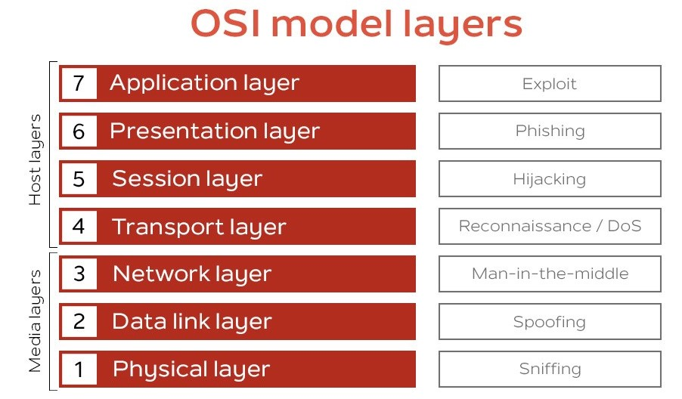

* **Application Layer:**

**Attacks :** DDoS, HTTP floods, SQLi, XSS, parameter tampering, viruses, worms, phishing, and Trojan horses.

**Mitigation:** Use WAFs, secure web gateways, and monitor applications for zero-day vulnerabilities to defend the Application Layer.

* **Presentation Layer:**

**Attacks:** SSL hijacking, encryption downgrade attacks, decryption attacks, encoding attacks, DDoS attacks.

**Mitigation**: Offload SSL, inspect application traffic for attacks, and use an application delivery platform (ADP) for re-encryption and forwarding.

* **Session Layer:**

**Attacks:** Session hijacking, Man-in-the-Middle (MITM), Blind attack, Man-in-the-browser, and SSH sniffing pose security risks.

**Mitigation:** Regularly check for updates and patches from your hardware provider to neutralize potential threats and vulnerabilities.

* **Transport Layer:**

**Attacks**: TCP Sequence prediction, SYN flood, TCP session hijacking, UDP flood, and UDP-based amplification attacks pose risks to network security.

**Mitigation:** ISPs often employ DDoS blackhole routing/filtering (Blackholing) to mitigate attacks and divert malicious traffic to a void destination.

* **Network Layer:**

**Attacks:** IP spoofing, jamming, ICMP attack, Smurf attack, Worm-hole, Blackhole attacks, Sybil attack, packet sniffing, and selective forwarding pose security risks.

**Mitigation:** Keep security patches up to date, enable packet filtering, block unused ports/services/interfaces, use firewalls, enable logging, and encrypt switch traffic.

* **Data Layer:**

**Attacks:** ARP Spoofing, MAC cloning, DoS, Spanning tree attack, VLAN hopping, DHCP attacks.

**Mitigation:** Limit DHCP response ports, use static ARP, install Intrusion Detection Systems (IDS), authenticate MAC addresses against AAA, and apply MAC address filtering.

* **Physical Layer:**

**Attacks:** Unauthorized access, data sniffing, and physical damage pose threats to network and system integrity.

**Mitigation:** Implement defense-in-depth strategies, including access controls, accountability measures, and auditing practices to track and control physical assets and mitigate security risks.

Awareness and understanding of exploits are crucial initial steps in the cybersecurity realm for addressing security issues.

* **Case Study Summaries:**
* **Target Corporation Data Breach (2013):**

**Attack:** The attack involved a combination of social engineering, malware injection, and network exploitation, targeting the Application and Data Link layers.

**Impact:** Over 40 million credit and debit card details were compromised, leading to financial losses and reputational damage for Target Corporation.

* **Stuxnet Worm (2010):**

**Attack:** Stuxnet targeted the Physical, Data Link, and Application layers. It exploited zero-day vulnerabilities to infiltrate industrial control systems (ICS) used in Iran's nuclear facilities.

**Impact:** The worm caused physical damage to centrifuges, disrupting Iran's nuclear program, and highlighted the vulnerability of critical infrastructure to cyberattacks.

* **Equifax Data Breach (2017):**

**Attack:** Exploiting a vulnerability in the Apache Struts framework, attackers gained access to sensitive data, targeting the Application and Data Link layers.

**Impact:** Approximately 147 million individuals' personal and financial information was exposed, resulting in substantial financial and reputational damage to Equifax.

* **Mirai Botnet (2016):**

**Attack:** The Mirai botnet launched massive Distributed Denial of Service (DDoS) attacks on IoT devices, targeting the Network and Physical layers.

**Impact:** The attacks disrupted major websites and services, causing widespread internet outages and highlighting the security risks associated with insecure IoT devices.

* **NotPetya Ransomware (2017):**

**Attack:** NotPetya exploited vulnerabilities in the Windows operating system, spreading rapidly through networks, targeting the Network, Transport, and Application layers.

**Impact:** It caused widespread disruption, including financial losses exceeding billions of dollars, affecting numerous organizations globally.

**NOTE:** It provide examples of attacks at various layers of the OSI model, showcasing the real-world impacts and consequences of such security breaches.

* **Recommendations for Defending Against Attacks:**

Recommendations for defending against attacks targeting the OSI model, emphasizing the importance of defense-in-depth strategies, network segmentation, regular security audits, employee education and awareness, and staying up to date with security best practices and technologies.

* **Implement Defense-in-Depth:** Employ multiple layers of security controls at each OSI layer to create a robust defense system.
* **Network Segmentation:** Divide your network into isolated segments to limit the impact of an attack and prevent lateral movement.
* **Regular Security Audits:** Conduct frequent security assessments and audits to identify vulnerabilities and address them promptly.
* **Employee Education and Awareness:** Train employees on best security practices, such as recognizing phishing attempts and practicing strong password hygiene.
* **Stay Up to Date:** Keep systems, software, and security solutions updated with the latest patches and upgrades to mitigate known vulnerabilities.
* **Access Control and Authentication:** Enforce strong access controls, implement multi-factor authentication, and regularly review user permissions.
* **Intrusion Detection and Prevention Systems:** Deploy IDS/IPS to monitor and respond to suspicious activities and attacks in real-time.
* **Encryption and Secure Protocols**: Utilize encryption mechanisms and secure protocols (e.g., SSL/TLS) to protect data in transit and at rest.
* **Incident Response Plan:** Develop and regularly test an incident response plan to efficiently handle security incidents and minimize damage.
* **Vendor Security:** Ensure third-party vendors follow robust security practices and perform due diligence before integrating their products or services.
* **Backup and Recovery:** Regularly backup critical data and systems, and test the restoration process to ensure business continuity in case of an attack.
* **Continuous Monitoring:** Implement security monitoring tools and solutions to detect and respond to suspicious activities promptly.

Cyber security is a continuous effort; adapt and evolve defenses to counter emerging threats effectively.

**Conclusion:** Safeguarding each layer of the OSI model is vital for secure network communications. By understanding attacks and implementing appropriate defenses, organizations can mitigate risks, protect data integrity, and ensure a resilient cybersecurity posture. Ongoing vigilance, regular updates, and a proactive approach are key to staying ahead of emerging threats and maintaining a robust network security infrastructure.